DSA ASSIGNMENT 01
Ques 6.
Sol 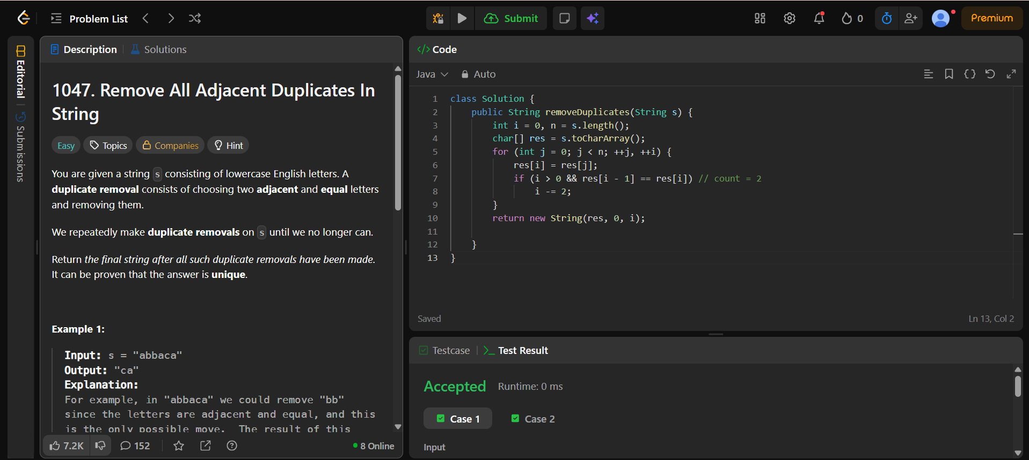

Ques7.
Sol 

